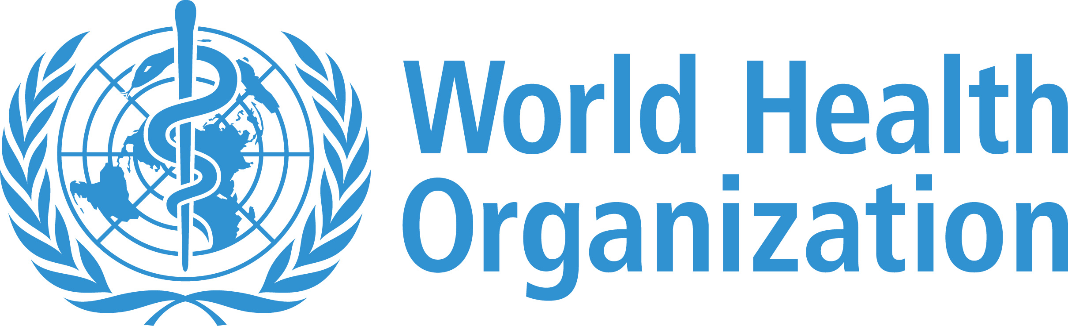
Banking Services to WHO’s Direct Disbursement Mechanism (DDM) – 2017/18)__ Request for Proposals
Acceptance Form

The Undersigned, ……………………….., confirms to have read, understood and accepted the terms of the Accounting Services to WHO’s Direct Disbursement Mechanism (DDM) – 2017/18 Request for Proposals (RFP) No. BS-2016-01, and its accompanying documents. If selected by WHO for the work, the Undersigned undertakes, on its own behalf and on behalf of its possible partners and contractors, to perform Accounting Services to WHO’s Direct Disbursement Mechanism (DDM) – 2017/18 in accordance with the terms of this RFP and any corresponding contract between WHO and the Undersigned, for the following sums:

Item | Cost (Indicate Currency)
One-Time Costs/Professional Fees
 | 0.00
 | 0.00
 | 0.00
 | 0.00
 | 0.00
 | 0.00
 | 0.00
 | 0.00
 | 0.00
 | 0.00
Total Other Costs | 0.00
Total Proposed One-Time Cost | 0.00
Recurring Costs
 | 0.00
 | 0.00
 | 0.00
 | 0.00
 | 0.00
 | 0.00
 | 0.00
Total Proposed Recurring Cost | 0.00

The enclosed Proposal is valid for _______________ days from the date of this form.

Agreed and accepted, in four (4) original copies on _______________ [date]

Bidder Name:
Mailing Address:

Name and Title of duly authorized representative:
Signature: Date:
Bidder's Stamp
or Seal (if relevant):

